Date: March 29, 2023
To: City of Crisfield Mayor, Darlene Taylor; City Grant Administrator, Jen Merritt
Subject: Assessment of the City of Crisfield’s Stormwater System Vulnerability to Increased Precipitation and Sea Level Rise Using EPA’s Climate Resilience Evaluation and Awareness Tool (CREAT 3.0)

Key Takeaways and Objectives
The City of Crisfield worked with the Environmental Protection Agency (EPA) to conduct a risk assessment for flooding utilizing EPA’s Climate Resilience Evaluation and Awareness Tool (CREAT). The increasing intensity and frequency of heavy precipitation events, tidal flooding, sea level rise, and coastal storm surge make it critical for Crisfield to address system capabilities to provide reliable stormwater management. Crisfield joined two other Maryland communities, the City of Cambridge and the Town of Chesapeake Beach, to explore how these other systems in the Chesapeake Bay region are impacted by, and how they are addressing, flooding.
The objective of this memo is to capture the CREAT exercise process and outcomes. The memo provides tangible information to stakeholders to help determine appropriate next steps based on the assessment’s results. CREAT results can assist Crisfield in assessing and advancing implementation of projects outlined in the City’s Drainage Assessment Report. Crisfield can also use the results to inform funding applications for improving the drainage system’s climate resilience.
Key takeaways include:
- Without implementing new strategies, for the South Somerset Avenue area alone, Crisfield could face annual flood-related costs of $393,324 - $782,624 by the year 2050 under a Baseline Climate scenario, and $9,543,619 or more under a Higher Rainfall, Stormier, and Sea Level Rise Climate scenario.
- Implementing a plan for improved ditch maintenance could result in annual monetized risk reduction of $233,662 - $658,062 under a Baseline Climate scenario, and $7,889,810 or more under a Higher Rainfall, Stormier, and Sea Level Rise Climate scenario.
- Implementing a plan to convert this portion of the system to closed pipes could result in annual monetized risk reductions of $287,224 - $711,624 under a Baseline Climate scenario, and $8,420,310 or more under a Higher Rainfall, Stormier, and Sea Level Rise Climate scenario
- Given that the entire stormwater system could be consistently inundated due to sea level rise beyond a certain threshold, the assessment considered additional flood protection measures to prevent sea level rise-induced inundation.

Context
Many coastal communities in the Chesapeake Bay region have historically faced flooding threats, which are expected to worsen due to climate change. The three coastal municipalities of Crisfield, Cambridge, Chesapeake Beach face ongoing impacts from coastal storm surge, intense precipitation events, tidal flooding (king tides), and sea level rise. Flooding caused by both more intense precipitation events and sea level rise are increasingly overwhelming the municipalities’ stormwater systems and affecting the ability of their wastewater systems to provide reliable services.
Crisfield has developed a Drainage Assessment Report to examine fifteen of the city’s highest priority areas for flooding. The report outlines project options to address the increasing flood risk and build resilience for the community and its critical infrastructure. The City has secured funding for many of these projects, and is seeking funding for its remaining proposed resilience projects.
EPA’s Climate Resilience Evaluation and Awareness Tool (CREAT) informs decision-making and helps identify climate adaptation options to build stormwater, drinking water, and wastewater systems’ resilience in the face of climate change impacts. CREAT provides a clear monetized risk reduction evaluation that can well position a system to apply for grant funding. Crisfield utilized CREAT to understand the impacts of climate change, particularly the effects of high precipitation events and sea level rise on the South Somerset Avenue to Woodson School Road Drainage System, and the costs and benefits of potential adaptive measures. Using CREAT results, Crisfield can inform prioritization and implementation of projects in the Drainage Assessment Report and other planning efforts.

Current Concerns

Sector Water / Service Needs
Crisfield noted that access to the local hospital is blocked during high-flooding events, making it challenging for emergency vehicles to pass through. This negatively impacts community public health in Crisfield, as emergency services are unable to provide timely responses during these potentially life-threatening events.
Sea Level Rise
The City of Crisfield is located at very low elevation (~1-4ft above mean sea level) along the coast of the Chesapeake Bay. Sea level rise is a current and future concern, as it continues to increase and contribute to intense flooding, which overwhelms the stormwater system and reduces its effectiveness.
Crisfield also selected Natural Disasters, Peak Service Challenges, Water Quality Management, and Ecosystem/Landscape Management as areas of concern for their stormwater system.

Introduction to CREAT
CREAT provides climate projection data within a risk assessment framework to help water utilities and systems assess risks from climate-related threats and evaluate potential adaptation options for implementation. Within CREAT, users assess consequences from climate-related threats that can impact system assets and operations, and then estimate the monetized benefits of implementing adaptation options to improve resilience to those threats. At the end of a CREAT assessment, users can compare the estimated monetized risk reduction obtained by implementing adaptive measures against the cost of implementing those measures. The results of a CREAT assessment provide information that systems and municipalities can use to inform future investments and long-term planning.

CREAT Assessment Scope for Crisfield
With technical assistance from EPA, Crisfield conducted a CREAT risk assessment for vulnerable aspects of their stormwater system. Crisfield provides stormwater services for a population of approximately 2,400. The system is designed to handle flow from an average storm of about 1 million gallons per day (MGD). Around 90% of the stormwater drainage system is open channel (i.e., ditches), with the remaining 10% consisting of closed pipe (i.e., tile). Challenges with maintaining the ditch systems include legal access (easements), a preponderance of Phragmites, and historic sedimentation. There are no “as-built” drawings, and it is unclear whether the ditches are appropriately graded.
The majority of Crisfield lies within a 100-year floodplain, with many areas having elevation levels at just one to four feet above mean sea level. Coastal storm surge, sea level rise, and tidal flooding are the major concerns for these low elevations, and all three are projected to worsen over time due to climate change. To avoid significant impacts to infrastructure and assets, Crisfield’s drainage system will need to have the capability to efficiently remediate flooding that occurs from these events. In 2021, the City commissioned a Drainage Assessment Report to evaluate the components of the drainage system, impacts from flooding events, and potential mitigation alternatives (Bayland Consultants & Designers, Inc., 2021). The drainage system comprises roadside and non-roadside swales with storm drain infrastructure that discharge to 40 tidal outfalls located throughout the city. Many of the tidal outfalls are ineffective as they are overgrown with vegetation, filled with sediment, or submersed -- even during low tide conditions.
Due to a lack of tidal gates for many of the outfalls, there is continuous backwatering of the system, reducing drainage capacity for rainfall runoff and allowing sedimentation to accumulate. In addition, many of the pipes throughout the drainage system are undersized, further exacerbating these issues and causing localized flooding throughout the community, with some areas impacted more than others. The South Somerset Ave to Woodson School Road area, which is at one of the lowest elevations in the city, is susceptible to flooding due to runoff from multiple large areas. The flooding impacts major roadways and infrastructure, including an elementary school.
For the CREAT assessment, Crisfield considered the impacts of floods, with a focus on increased precipitation and sea level rise on the South Somerset Ave to Woodson School Road area drainage system.

Crisfield’s CREAT Exercise Process
The CREAT exercise process began with a Kickoff Call in November 2022 to organize the exercise and understand the three municipalities’ goals for the assessment. Across four working sessions that took place from January 2023 to February 2023, Crisfield, Cambridge, Chesapeake Beach, and EPA worked through the five CREAT modules and conducted an on-site visit from January 11-13 to better understand the relevant vulnerable infrastructure and concerns. The results of Crisfield’s analysis are explained in this memo. In addition to this memo, the CREAT exercise resulted in a case study and a regional workshop to highlight how EPA’s CREAT framework can help inform municipality and regional planning.

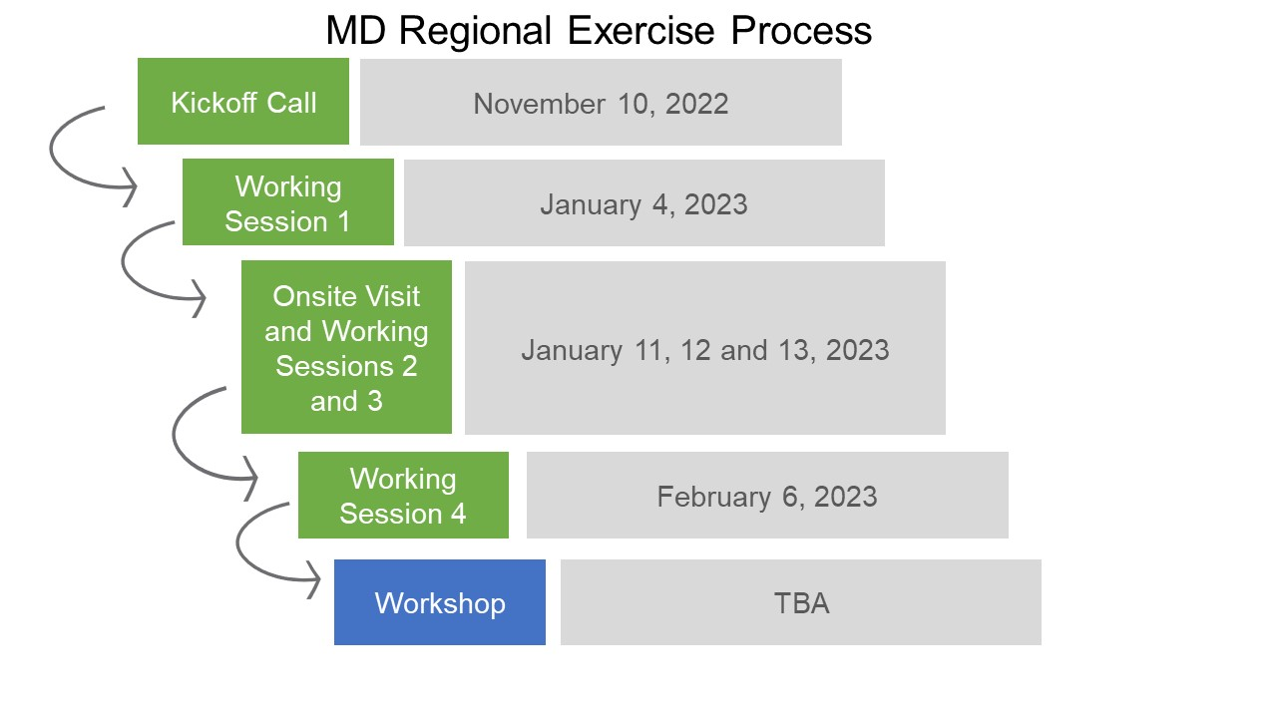
Figure 1. Maryland Regional CREAT Exercise Process
Jen Merritt (Grant Administrator) led the assessment for Crisfield and, along with colleagues, provided detailed knowledge of the system structure, operations, assets, vulnerabilities, history of flooding, and existing and potential adaptive measures.

CREAT Assessments Components
A CREAT assessment comprises five modules that build on one another and are completed sequentially. Each module is customized by the user according to the scope and intentions of the assessment. The following sections describe each module along with the values and assumptions entered in Crisfield’s assessment.
Climate Awareness Module: The user begins the assessment by adding information about their system, including population served, location, and system type. The user reviews climate observations and projections in their region and identifies current concerns. Crisfield selected Peak Service Challenges, Water Quality Management, Natural Disasters, Ecosystem / Landscape Management, Sector Water / Service Needs, and Sea Level Rise (SLR) as their primary concerns.

Crisfield Entries
Address: 319 West Main Street (City Hall)
Ownership: Publicly Owned
Financial Condition: Midrange
Estimated population served: 2,400
System Type: Combined Wastewater
- Estimated millions of gallons per day (MGD): 1
- Current Concerns: Peak Service Challenges, Water Quality Management, Natural Disasters, Ecosystem / Landscape Management, Sector Water / Service Needs, and Sea Level Rise
Scenario Development Module: The user then establishes a historical climate baseline and determines which climate scenario(s) to consider over a set planning horizon. For Crisfield, climate scenarios included both a “Baseline” scenario to capture current conditions and a “Higher Rainfall, Stormier, and SLR” scenario. The latter scenario reflects conditions based on projected model runs. For example, the Higher Rainfall, Stormier, and SLR scenario uses averaged outputs from individual model runs that reflect moderate projected changes in precipitation and moderate projected increases in temperature. For each scenario, the user has the option to use default climate values from CREAT or provide custom values, if available. Table A1 shows the data from Crisfield’s Baseline Climate scenario and Higher Rainfall, Stormier, and SLR climate scenario. The user also identifies specific climate threats such as flooding, droughts, and water quality degradation. For Crisfield, the identified threat was “Floods”. The threat designation “Floods” refers to the challenges with increasing storm frequency and intensity, coastal storm surges, and increases in sea level rise. All of these result in indunation of coastal areas, and can cause distuption of services and damage to infrastructure, challenging the ability of the municipality to provide adequate services.

Crisfield Entries
Threat: Floods
Baseline Scenario: Precipitation data derived from the Crisfield Somers Cove Station; coastal data from the Wachapreague, VA Tidal Gauge
Planning Horizon: 2023-2050
Projected Scenarios: Higher Rainfall, Stormier, SLR Climate Scenario

Consequences & Assets Module: CREAT provides the user with an Economic Consequences Matrix, which is initially populated with figures based on previous entries reflecting the municipality context. The default consequence categories include Utility Business Impacts, Utility Equipment Damage, Environmental Impacts, and Source/Receiving Water Impacts. Each of these categories includes a range of default cost values (e.g., based on available benchmark utility survey data). Alternatively, the user can revise these values based on available data. The user can also replace these categories, add custom consequence categories, choose which categories to monetize, and alter the monetized values for each of the consequence levels, as needed. The user completes the module by defining the asset(s) of their system (i.e., South Somerset Ave to Woodson School Road Drainage System) that are most vulnerable to the previously selected climate threat(s) (i.e., Floods).
Economic Consequences Matrix entries were interpreted as levels of impact, where the “Low” level reflects costs the municipality could financially absorb; the “Medium” level reflects costs for which the municipality would seek additional government funding; the “High” level reflects costs for which the municipality would need to go to the (bond) market; and the “Very High” level reflects costs to cover a major project requiring the municipality to borrow money and/or obtain grant funding. For broader assessments, EPA recommends looking at the municipality’s total annual budget versus considering the economic consequence for a particular asset.
Crisfield decided not to consider Utility Business Impacts; Environmental Impacts; or Source / Receiving Water Impacts at this stage. However, the municipality did consider and monetize Utility Equipment Damage and added a custom category, Loss of Community Function Due to Flooding.

Crisfield Entries
Table 1 presents the economic consequence levels for the two consequence categories that Crisfield chose to include.
Consequence Categories:
- Utility Equipment Damage: Costs of replacing the service equivalent provided by a utility or piece of equipment evaluated in terms of the magnitude of damage and financial impacts. Consequences range from complete loss of the asset to minimal damage to the equipment.
- Loss of Community Function Due to Flooding: Loss of community function due to flooding, including school closure and impacts to 50 households affected in the area. Consequences range from one day of disruption up to more than 10 days of disruption.

Table 1. Economic Consequences Matrix (Annual)
Consequence Categories | Levels
 | Low | Medium | High | Very High
Utility Equipment Damage | Minimal damage to equipment | Minor damage to equipment | Significant damage to equipment | Complete loss of asset
 | $0 - $71,000 | $71,000 - $177,000 | $177,000 - $424,000 | > $424,000
Loss of Community Function Due to Flooding | 0-1 day  disruption | 2-5 day disruption | 5-10 day  disruption | More than 10 days of disruption
 | $0 - $106,100 | $212,000 - $530,500 | $530,500 - $1,061,000 | > $1,061,000

Crisfield chose to consider regional economic consequences in their assessment. The city incorporated this to account for broader impacts due to flood-related school closures, including impacts to parents when children cannot attend school. With this selection, CREAT populated the state economic loss per capita as $111.59 during an event.
Crisfield chose to consider public health consequences quantitatively in their assessment, since flooding has previously impacted public health. For example, as noted above, emergency vehicles have been unable to access certain locations or roads due to flooding impacts.
Crisfield Entries (continued)
Table 2 presents the assigned threat for Crisfield’s vulnerable asset: South Somerset Ave to Woodson School Road Drainage System
Table 2. Asset/Threat Identification for Crisfield
Asset Name | Assigned Threat | Critical Asset? | Definition
South Somerset Ave to Woodson School Road Drainage System | Floods | Yes | South Somerset Ave to Woodson School Road Drainage System - see page 21 of Drainage Assessment Report

Adaptation Planning: In the fourth module, the user identifies their utility’s “Existing Adaptive Measures” and groups them together to comprise the “Current Measures” adaptation plan. The user then identifies “Potential Adaptive Measures”, and these are grouped together to form additional adaptation plans. The user enters annualized implementation costs for each measure, and the costs are aggregated to capture the total cost for implementing each adaptation plan. Table 3 shows Crisfield’s Existing and Potential Adaptive Measures, and Table 4 shows the Adaptation Plans.
Crisfield Entries
Table 3. Existing and Potential Adaptive Measures
Name | Annual Cost | Description
Existing Adaptive Measures
Infrastructure Monitoring and Inspection | N/A* | Infrastructure Monitoring and Inspection
Potential Adaptive Measures
Convert to Closed System | $1,250,000 - $1,750,000 | 2,000 linear feet at $500/ft = $10,000,000 for double or triple pipes; annualized to $1,250,000 - $1,750,000, assuming 30-year loan term at 4% and 10% annual O&M costs
Ditch Maintenance | $15,000 - $25,000 | Ditch Maintenance includes annual dredging of the ditches (City staff time at $75K annual ditching & $30K annual dump truck driving, or hiring of a contractor).  There are also annualized one-time costs for the following:  - a consultant to secure location for dredge material and do permitting;  - equipment to perform dredging, excavator ($200K), dump truck ($150K);  - a consultant to secure easements for ditches;  - an engineer to determine appropriate grade;  - and City staff time or a contractor to create a maintenance plan.  The actual cost is calculated as 10% of this total, given that the South Somerset Ave to Woodson School Road area is ~10% of the total system.

* Crisfield decided to not include the cost estimate for the existing adaptive measure, because the costs for existing adaptive measures are not used for any CREAT calculations.

Crisfield Entries
Table 4 represents Crisfield’s adaptation plans. Crisfield chose to separate out the two potential adaptive measures and create an adaptation plan for each one.
Table 4. Crisfield’s Adaptation Plans
Plan Name | Definition | Relevant Threats | Total Annualized Cost
Current Measures | Includes the Existing Adaptive Measure of Infrastructure Monitoring and Inspection | Floods | N/A
Ditch Maintenance | Includes the Ditch Maintenance Potential Adaptive Measure | Floods | $15,000 - $25,000
Convert to Closed System | Includes the Convert to Closed System Potential Adaptive Measure | Floods | $1,250,000 - $1,750,000

Risk Assessment: In the final module, the user assigns consequence levels to their assets given the implementation of each adaptation plan under each projected climate scenario. The user can then compare the range of annual consequence costs based on either the Current Measures plan or implementing the new adaptation plans. The module provides graphs for visual representations of each adaptation plan’s total annual monetized risk reduction against the annual cost of each adaptation plan across climate scenarios.
Crisfield Asset/Threat Pairs: Crisfield analyzed the impact of the two adaptation plans on the South Somerset Ave to Woodson School Road Drainage System under the two climate scenarios. Table 5 shows the economic impacts of floods under the Baseline Climate scenario and a Higher Rainfall, Stormier, and SLR scenario for the Current Measures plan (measures that have already been implemented). Table 6 shows the impacts of Floods with the Ditch Maintenance plan implemented. Table 7 shows the impacts of Floods with the Convert to Closed System plan implemented. Each table also includes the regional economic and public health consequences.
Table 5. Asset/Threat Pair Assessment for South Somerset Ave to Woodson School Road Drainage System; Current Measures
Asset: South Somerset Ave to Woodson School Road Drainage System; Current Measures
Plan Name: | Current Measures
Scenario: | Baseline Climate Scenario | Higher Rainfall, Stormier, and SLR Climate Scenario
Annual Economic Consequences
Utility Equipment Damage | Low | High
 | $0 - $71,000 | $177,000 - $424,000
Loss of Community Function Due to Flooding | Medium | Very High
 | $212,000 - $530,500 | >$1,061,000
Total Economic Consequences | $212,000 - $601,500 | >$1,238,000
Annual Regional Economic Consequences
Duration of Service Outages (Days) | 2 | 10
Customers without Service (%) | 20 | 20
Total Regional Economic Consequences | $107,124 | $535,619
Annual Public Health Consequences
Number of Fatalities | 0 | 1
Number of Injuries | 1 | 5
Total Public Health Consequences | $74,000 | $7,770,000

Table 6. Asset/Threat Pair Assessment for South Somerset Ave to Woodson School Road Drainage System; Ditch Maintenance
Asset: South Somerset Ave to Woodson School Road Drainage System; Ditch Maintenance
Plan Name: | Ditch Maintenance
Scenario: | Baseline Climate Scenario | Higher Rainfall, Stormier, and SLR Climate Scenario
Annual Economic Consequences
Utility Equipment Damage | Low | High
 | $0 - $71,000 | $177,000 - $424,000
Loss of Community Function Due to Flooding | Low | High
 | $0 - $106,100 | $530,500 - $1,061,000
Total Economic Consequences | $0 - $177,100 | $707,500 - $1,485,000
Annual Regional Economic Consequences
Duration of Service Outages (Days) | 1 | 5
Customers without Service (%) | 20 | 20
Total Regional Economic Consequences | $53,562 | $267,809
Annual Public Health Consequences
Number of Fatalities | 0 | 0
Number of Injuries | 0 | 2
Total Public Health Consequences | $0 | $148,000

Table 7. Asset/Threat Pair Assessment for South Somerset Ave to Woodson School Road Drainage System; Convert to Closed System
Asset: South Somerset Ave to Woodson School Road Drainage System; Convert to Closed System
Plan Name: | Convert to Closed System
Scenario: | Baseline Climate Scenario | Higher Rainfall, Stormier, and SLR Scenario
Annual Economic Consequences
Utility Equipment Damage | Low | Medium
 | $0 - $71,000 | $71,000 - $177,000
Loss of Community Function Due to Flooding | Low | Medium
 | $0 - $71,000 | $212,200 - $530,500
Total Economic Consequences | $0 - $177,100 | $283,200 - $707,500
Annual Regional Economic Consequences
Duration of Service Outages | 0 | 5
Customers without Service (%) | 0 | 20
Total Regional Economic Consequences | $0 | $267,809
Annual Public Health Consequences
Number of Fatalities | 0 | 0
Number of Injuries | 0 | 2
Total Public Health Consequences | $0 | $148,000

Exercise Outcomes and Takeaways
Figure 2 through Figure 5 below (along with Figure A1 through Figure A4 in Appendix A) show the CREAT risk assessment results for Crisfield’s exercise. Each block is a financial impact range: the red block indicates Crisfield’s anticipated total annual economic consequences of Floods with existing adaptive measures; the orange block indicates the economic consequences of Floods after implementing either the Convert to Closed System or Ditch Maintenance plan; the green block indicates the range of reduced monetized risk from adaptation plan implementation; and the gray bar indicates the total cost of the adaptation plan.
The Ditch Maintenance plan would be beneficial to implement under either climate scenario. Under current climate conditions, captured by the Baseline Climate scenario, the Ditch Maintenance plan would be the most cost effective and result in a positive return on investment (Figure 2 and Figure 3). Crisfield is already facing significant challenges, as reflected by Loss of Community Function Due to Flooding currently exceeding low levels (Table 5). If Crisfield were to implement the Ditch Maintenance plan, this would significantly reduce economic consequences under current climate conditions, while also improving resilience to flooding under the Higher Rainfall, Stormier, and SLR Climate scenario (Figure A1 and Figure A2). Table A2 shows the values for annual consequences, total annual monetized risk reduction, and total annual adaptation plan costs across all plans and both chosen climate scenarios.
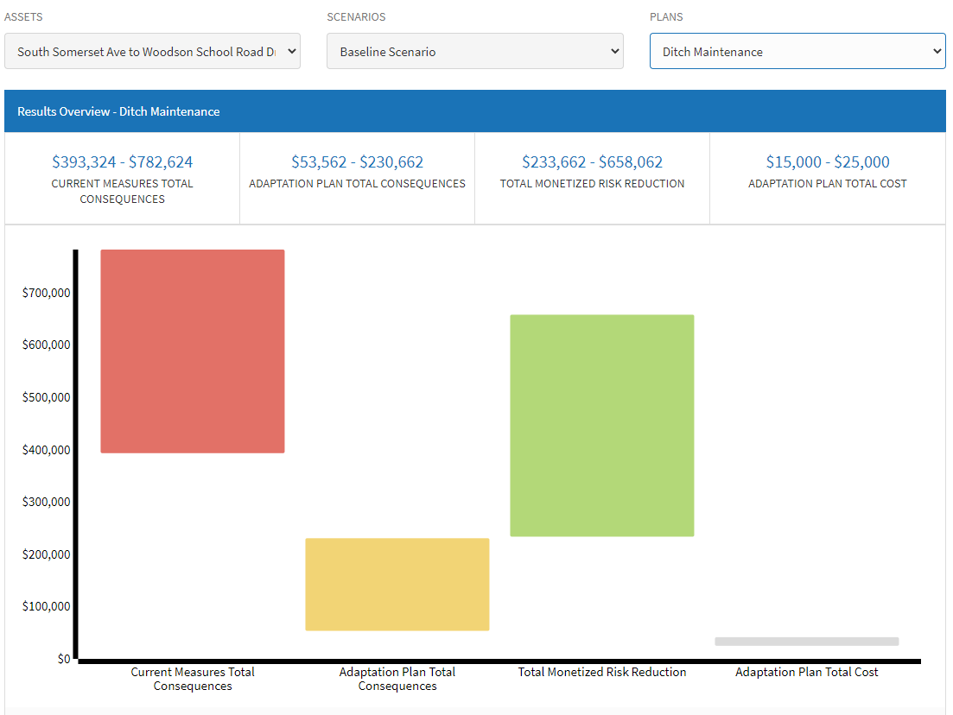
Figure 2. Illustrative Monetized Risk Reduction for the Ditch Maintenance Plan under a Baseline Climate Scenario
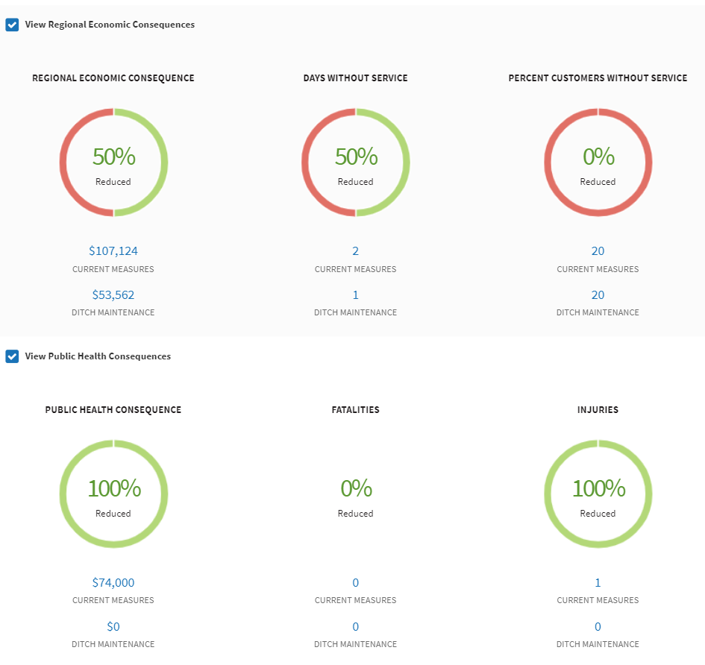
Figure 3. Illustrative Regional Economic and Public Health Consequences for the Ditch Maintenance Plan under a Baseline Climate Scenario

While the Convert to Closed System plan is more expensive than the Ditch Maintenance plan, the closed system results in a more significant reduction in consequences. As such, while the Convert to Closed System is not cost effective under the Baseline Climate scenario (Figure A3 and Figure A4), the plan is cost effective and results in significant reduction in total annual monetized risk under the Higher Rainfall, Stormier, and SLR Climate scenario (Figure 4 and Figure 5).

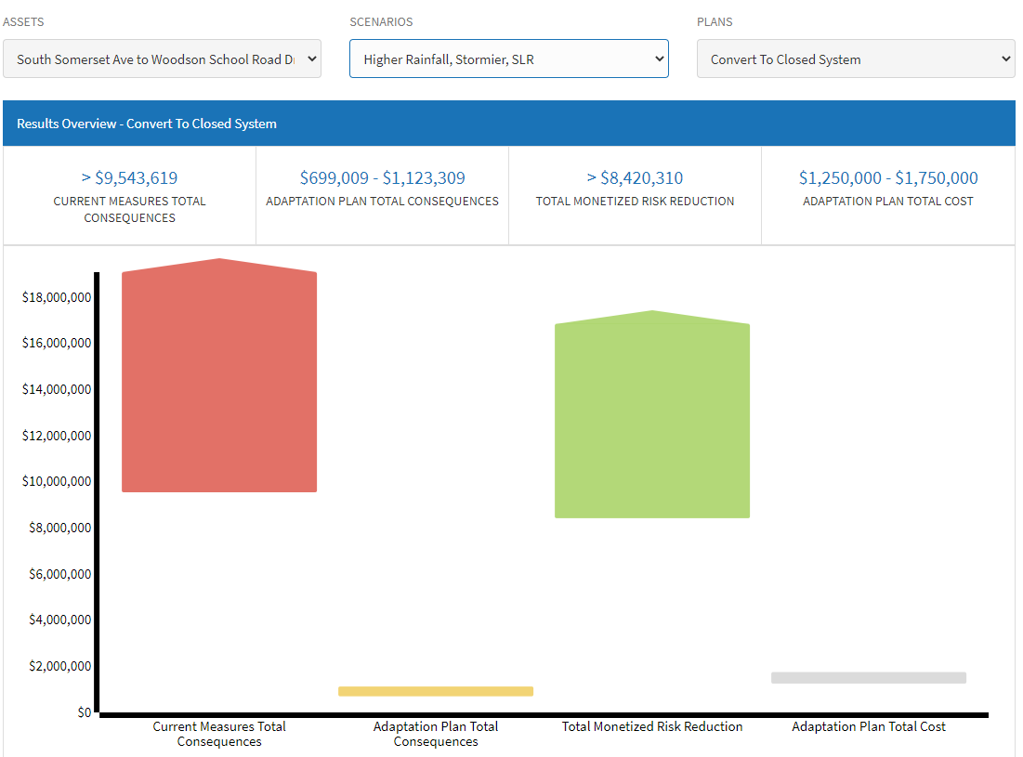
Figure 4. Illustrative Monetized Risk Reduction for the Convert to Closed System Plan under a Higher Rainfall, Stormier, and SLR Climate Scenario

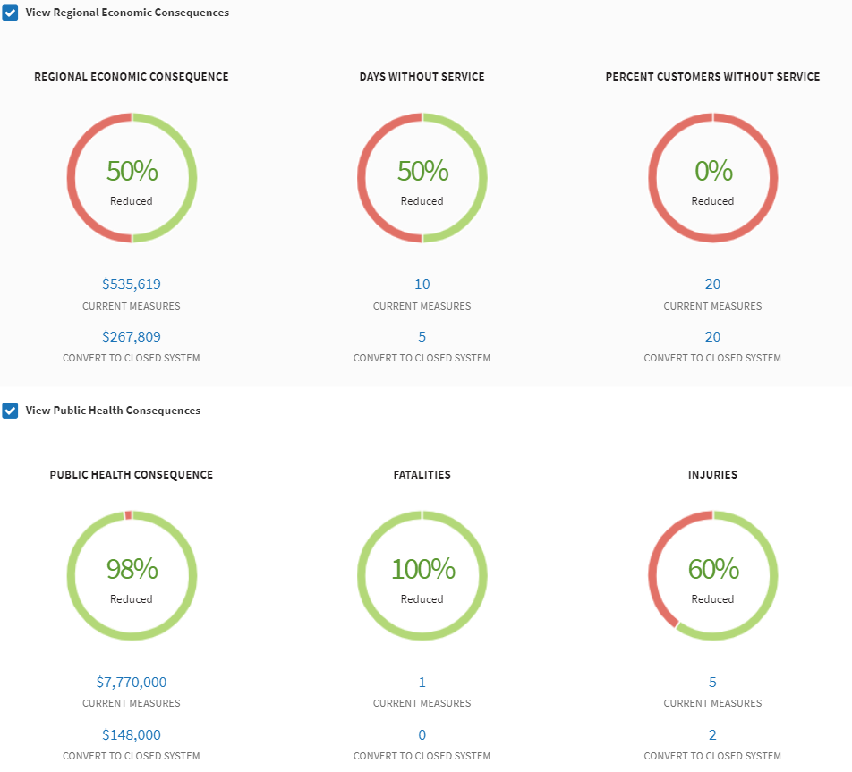
Figure 5. Illustrative Regional Economic and Public Health Consequences for the Convert to Closed System Plan under a Higher Rainfall, Stormier, SLR Climate Scenario
Crisfield also completed a qualitative plan comparison (see Table 8) that incorporates externalities that could impose additional costs on, or provide benefits to, consumers or the system. These include energy impacts and socio-economic impacts, as well as any consequence categories the user did not monetize in the Economic Consequences Matrix. There would be energy savings if Crisfield were to implement either plan. Both plans would improve effectiveness of the drainage system, which would result in positive impacts across Socio-Economic, Utility Business, and Source/Receiving Water categories. The Environmental Impacts are noted as neutral because this category captures environmental fines and fees, which are not currently levied for the South Somerset Ave to Woodson School Road area.
Table 8. Qualitative Impacts for Crisfield’s Adaptation Plans
Plan | Total Cost (Annual) | Energy Impacts | Socio-Economic Impacts | Utility Business Impacts | Environmental Impacts | Source/Receiving Water Impacts
Ditch Maintenance | $15,000 - $25,000 | Energy Savings | Beneficial | Beneficial | Neutral | Beneficial
Convert to Closed System | $1,250,000 - $1,750,000 | Energy Savings | Beneficial | Beneficial | Neutral | Beneficial

Considering Different Planning Horizons
In conducting the CREAT assessment, Crisfield recognized that projected sea level rise could render the ditches and pipes inoperable before 2050. To address this concern, Crisfield explored two separate scenarios, each with a different planning horizon (i.e., 2040 and 2050) aligned with a different degree of sea level rise and increase in intense precipitation. This was completed as a demonstration to better understand how the different planning horizons could affect the results, particularly around the need for more extensive flood protection measures against sea level rise over a longer time horizon.
Crisfield considered a 2040 scenario in which the increases in sea level, precipitation, and intense precipitation events were less significant than the original values selected for the 2050 time horizon. While Crisfield input a sea level rise value of 1ft, additional research is necessary to confirm the appropriate threshold for which the current ditch system or a closed system would be consistently overwhelmed and inundated by sea level rise. Crisfield considered a new adaptation plan called Flood Protect + Closed System, which reflects implementation of the closed system along with a significant investment in flood protection against sea level rise expected beyond 2040. The values for the new projected climate conditions and Flood Protect + Closed System costs were fully illustrative and require additional review.
As before, the Ditch Maintenance plan is cost effective even under the Baseline Climate scenario, while more expensive plans such as the Convert to Close System and Flood Protect + Closed System would not show a positive return on investment. While both the Ditch Maintenance plan and the Convert to Closed System plan would be cost effective under the 2040 climate scenario, neither plan would be effective under the 2050 climate scenario capturing the conditions over a longer time horizon. However, the new Flood Protect + Closed System plan would be cost effective and provide a return on investment under the 2050 climate scenario. This demonstration aided Crisfield with understanding how different adaptation plans could perform under the different planning horizons. The risk results and all associated figures from this demonstration can be found in Appendix B.

Recommendations and Next Steps
The selection of “Floods” as the consequence category in CREAT enabled Crisfield to assess Utility Equipment Damage and Loss of Community Function Due to Flooding on Crisfield’s critical asset, the South Somerset Ave to Woodson School Road Drainage System, under Current Measures and with the implementation of the Ditch Maintenance and Convert to Closed System plans. In doing so, Crisfield gained insight into the potential impacts of Floods in the absence of taking steps to build system resiliency, and of the potential range of financial risk reduction that may be achieved through the implementation of adaptive measures.
CREAT can also be a guide for how to present the potential consequences, relative benefits, and likelihood sensitivities (see Figure A5 through Figure A8) for a suite of potential adaptation measures. Using CREAT to prioritize planned projects could also be beneficial to Crisfield, particularly in determining the cost effectiveness of proposed annual dredging and other improvements included under the Ditch Maintenance plan. The visual representations and formatted reports provided by the tool could be used as Crisfield moves forward with understanding the relative benefits and consequences of various adaptation options.

Next Steps
As a next step, Crisfield may wish to further explore the two time horizon scenarios described above. Gathering additional data would be beneficial to help inform the sea level rise thresholds and adaptive measures to protect against worsening flooding. The flood depth modeling that The Nature Conservancy (TNC) and George Mason University have conducted could inform determination of appropriate thresholds. Crisfield could also include additional information on implementation strategies, timelines, and investments to understand the impacts of floods and sea level rise on the drainage system over the longer planning horizon.
Crisfield can expand the CREAT assessment to cover other components of the drainage system beyond the South Somerset Ave to Woodson School Road area. In particular, Crisfield could assess other projects outlined in the Drainage Assessment Report. Outputs could illustrate the degree to which projects would be cost effective under various climate conditions and time horizons, which could inform prioritization and decision making.

Funding
Crisfield is collaborating with TNC, the Federal Emergency Management Agency (FEMA), and the University of Maryland Environmental Finance Center (EFC). In addition, Crisfield has been working with Eastern Shore GIS to develop flood risk modeling. The CREAT results can complement and help inform these projects aimed at improving flood resilience for the city, including through funded activities.
While the Ditch Maintenance plan is a top priority for Crisfield, the city has not been successful in funding the proposed activities. Given the impact of flooding on the schools and emergency services, it could be valuable to reframe the Ditch Maintenance plan as protection of critical infrastructure. Integrating the consequence costs for emergency services requires additional documentation of impacts (e.g., ambulance delays due to flooding). Crisfield could also consider bundling the Ditch Maintenance plan activities with other projects to show a larger impact on the community; this could improve the likelihood to secure funding.
Relevant state-level contacts include:
- The EFC at the University of Maryland: Stephanie P. Dalke (spdalke@umd.edu)
- Maryland Department of the Environment: Jim George (jim.george@maryland.gov)
- Maryland Department of Planning: Jason Dubow (jason.dubow@maryland.gov) and Tracey Gordy (tracey.gordy@maryland.gov)
- Maryland Water & Sewer Infrastructure Financing: Jeffrey Fretwell (jeffrey.fretwell@maryland.gov)

Other agencies that may be able to provide support include:
- Water Infrastructure Finance and Innovation Act (WIFIA)
- FEMA
- State Revolving Funds (SRFs)
- Community Development Block Grant (CDBG)

Regional Workshops
Following the CREAT exercise, the EPA team will support a regional workshop to share the systems’ findings and experiences using the tool; learn from other municipalities facing similar flooding risks to better understand their impacts and resilience measures; and make connections with funding-related country, state, and Federal contacts. This regional workshop will illustrate the Maryland CREAT assessments in order to initiate conversations and action around climate resiliency on a regional basis.

Appendix A
Table A1. Values for Crisfield Baseline and Projected Climate Scenarios
 | Baseline Climate Scenario | Higher Rainfall, Stormier, SLR Climate Scenario
Precipitation Data
Average Annual Precipitation | 42.97 inches | 4.83% increase
Average January Precipitation | 3.89 inches | 7.64% increase
Average February Precipitation | 3.28 inches | 7.08% increase
Average March Precipitation | 4.45 inches | 8.14% increase
Average April Precipitation | 3.1 inches | 10.84% increase
Average May Precipitation | 3.63 inches | -2.65% decrease
Average June Precipitation | 3.18 inches | 1.77% increase
Average July Precipitation | 4.01 inches | 4.35% increase
Average August Precipitation | 3.93 inches | 3.23% increase
Average September Precipitation | 3.88 inches | 3.81% increase
Average October Precipitation | 3.35 inches | 0.01% increase
Average November Precipitation | 2.98 inches | 2.81% increase
Average December Precipitation | 3.31 inches | 10.2% increase
5-Year Intense Precipitation Event | 2.96 inches/24 hours | 8.82% increase
10-Year Intense Precipitation Event | 3.91 inches/24 hours | 9.13% increase
15-Year Intense Precipitation Event | 4.65 inches/24 hours | 9.54% increase
30-Year Intense Precipitation Event | 6.45 inches/24 hours | 10.52% increase
50-Year Intense Precipitation Event | 8.24 inches/24 hours | 11.42% increase
100-Year Intense Precipitation Event | 11.77 inches/24 hours | 12.84% increase
5-Year Intense Precipitation Event | 3.57 inches/72 hours | n/a

Table A1. Values for Crisfield Baseline and Projected Climate Scenarios
 | Baseline Climate Scenario | Higher Rainfall, Stormier, SLR Climate Scenario
Precipitation Data
10-Year Intense Precipitation Event | 4.38 inches/72 hours | n/a
15-Year Intense Precipitation Event | 4.96 inches/72 hours | n/a
30-Year Intense Precipitation Event | 6.25 inches/72 hours | n/a
Coastal Data
Total Sea Level Rise | 0 feet | 1.6 foot
Average Annual Number of Days with Tidal Flooding | 8 days | 271 days
Vertical Land Movement Annual | -.07 inches/year | n/a

Table A2. Risk Assessment Results for Crisfield’s Two Adaptation Plans for the South Somerset Ave to Woodson School Road Drainage System
Asset: South Somerset Ave to Woodson School Road Drainage System
 |  | Baseline Scenario | Higher Rainfall, Stormier, and SLR Scenario
Plan: Convert to Closed System | Current Measures Total Consequences | $393,324 - $782,624 | >$9,543,619
 | Adaptation Plan Total Consequences | $0 - $177,100 | $699,009 - $1,123,309
 | Total Monetized Risk Reduction | $287,224 - $711,624 | > $8,420,310
 | Adaptation Plan Total Cost | $1,250,000 - $1,750,000 | $1,250,000 - $1,750,000
Plan: Ditch Maintenance | Current Measures Total Consequences | $393,324 - $782,624 | >$9,543,619
 | Adaptation Plan Total Consequences | $53,562 - $230,662 | $1,123,309 - $1,900,809
 | Total Monetized Risk Reduction | $233,662 - $658,062 | >$7,889,810
 | Adaptation Plan Total Cost | $15,000 - $25,000 | $15,000 - $25,000

Additional Risk Results

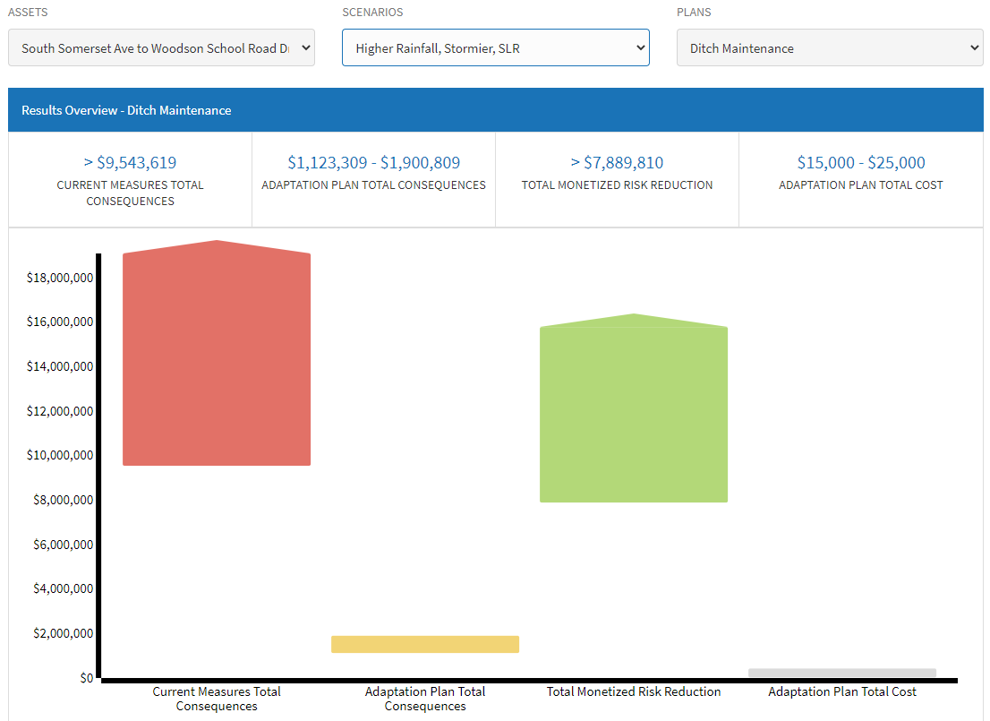
Figure A1. Illustrative Monetized Risk Reduction for the Ditch Maintenance Plan under a Higher Rainfall, Stormier, and SLR Climate Scenario
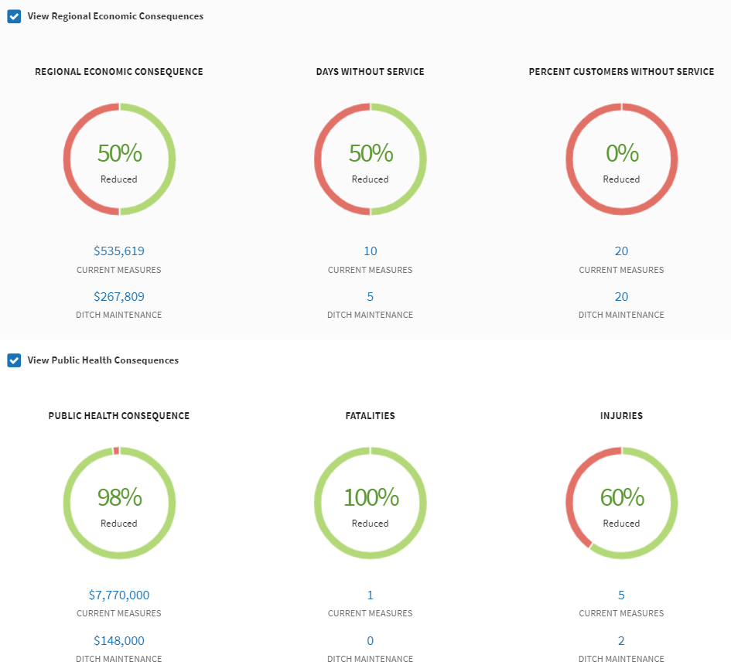
Figure A2. Illustrative Regional Economic and Public Health Consequences for the Ditch Maintenance Plan under a Higher Rainfall, Stormier, SLR Climate Scenario

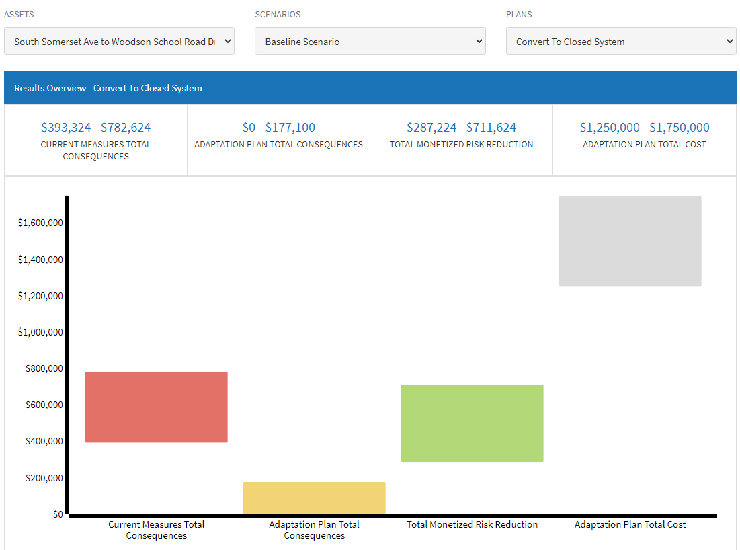
Figure A3. Illustrative Monetized Risk Reduction for Convert to Closed System Plan under a Baseline Climate Scenario
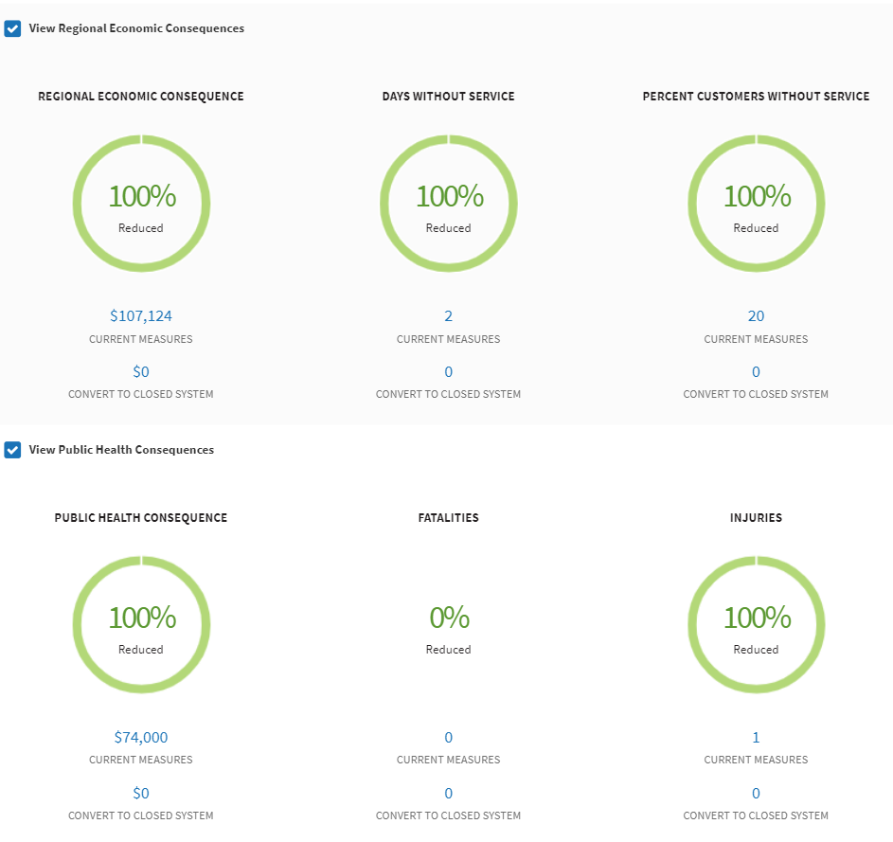
Figure A4. Illustrative Regional Economic and Public Health Consequences for the Convert to Closed System Plan under a Baseline Climate Scenario

Likelihood Sensitivity

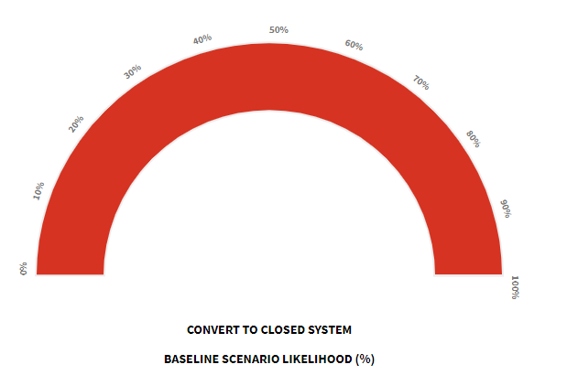
Figure A5. Convert to Closed System Plan under a Baseline Climate Scenario Likelihood

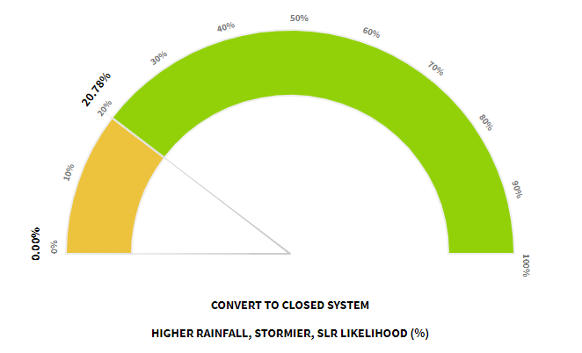
Figure A6. Convert to Closed System Plan under a Higher Rainfall, Stormier, and SLR Climate Scenario Likelihood

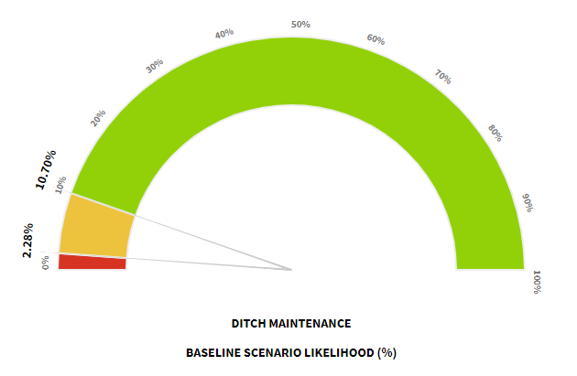
Figure A7. Ditch Maintenance Plan under a Baseline Climate Scenario Likelihood

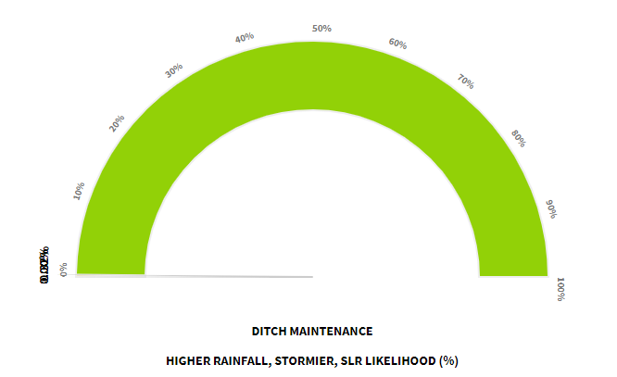
Figure A8. Ditch Maintenance Plan under a Higher Rainfall, Stormier, and SLR Climate Scenario Likelihood

Appendix B

Risk Results for Different Planning Horizons

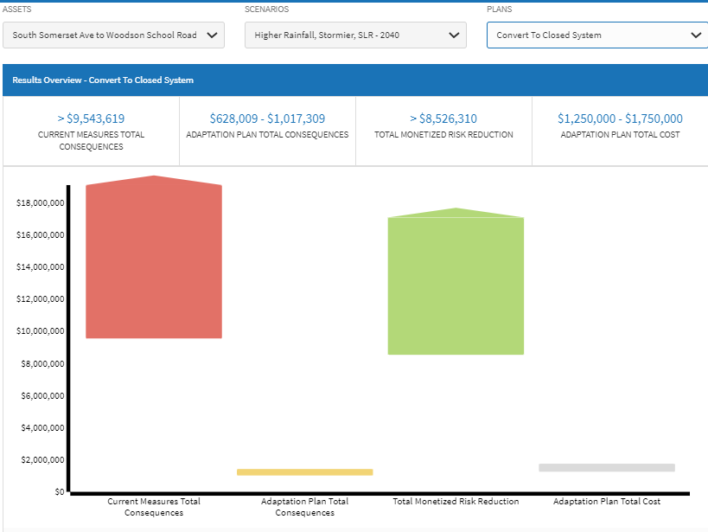
Figure B1. Illustrative Monetized Risk Reduction for Convert to Closed System Plan under a Higher Rainfall, Stormier, and SLR – 2040 Climate Scenario

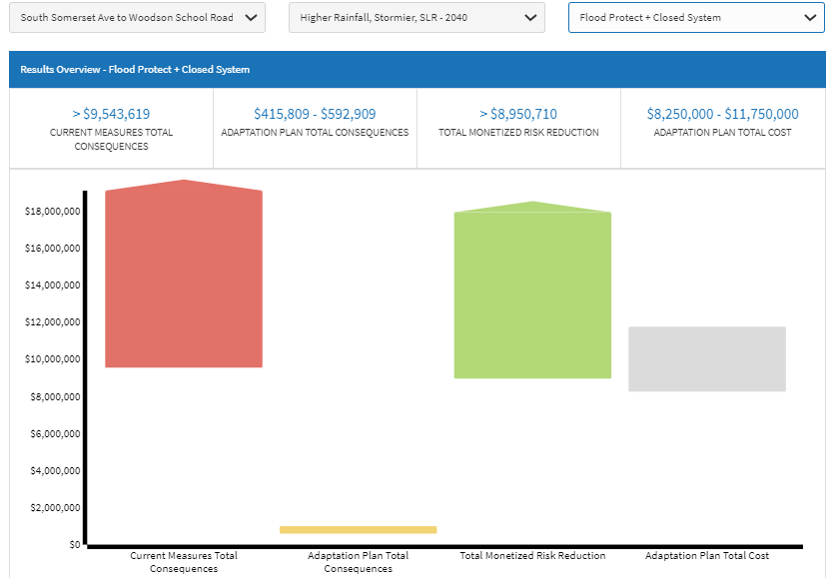
Figure B2. Illustrative Monetized Risk Reduction for Flood Protect + Closed System Plan under a Higher Rainfall, Stormier, and SLR – 2040 Climate Scenario
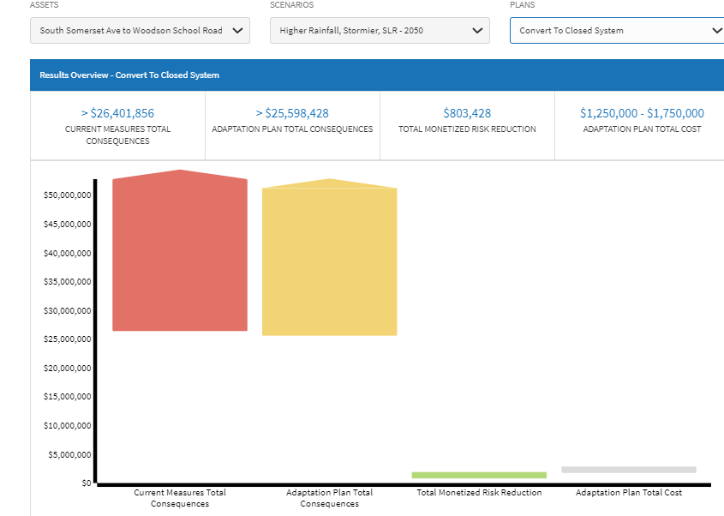
Figure B3. Illustrative Monetized Risk Reduction for Convert to Closed System Plan under a Higher Rainfall, Stormier, and SLR – 2050 Climate Scenario

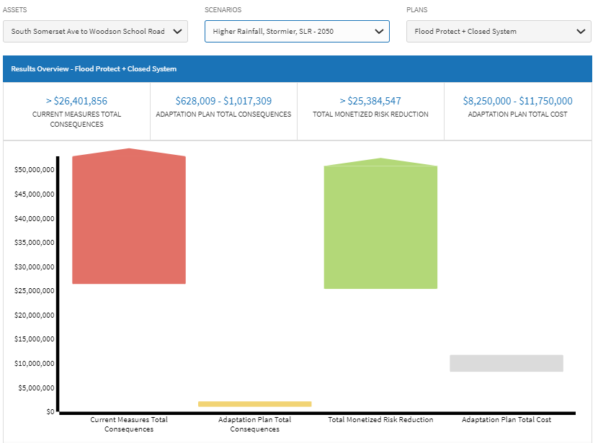
Figure B4. Illustrative Monetized Risk Reduction for Flood Protect + Closed System Plan under a Higher Rainfall, Stormier, and SLR – 2050 Climate Scenario

Regional Economic and Public Health Consequences

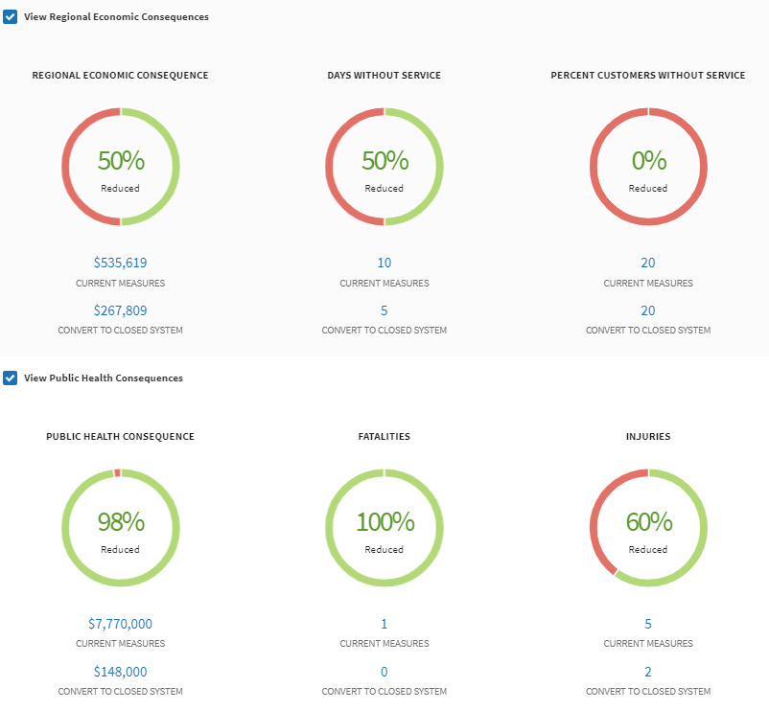
Figure B5. Illustrative Regional Economic and Public Health Consequences for the Convert to Closed System Plan under a Higher Rainfall, Stormier, SLR – 2040 Scenario

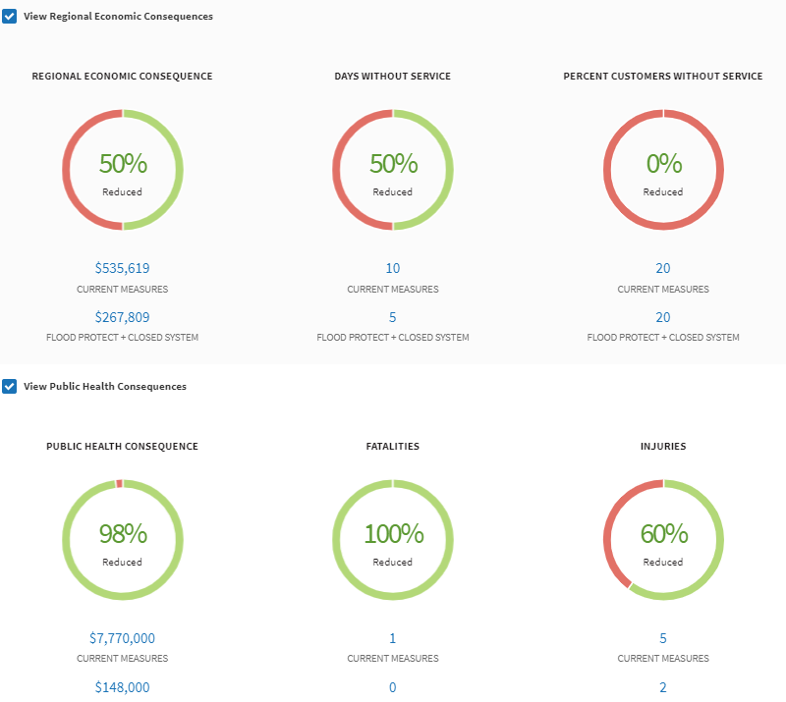
Figure B6. Illustrative Regional Economic and Public Health Consequences for the Flood Protect + Closed System Plan under a Higher Rainfall, Stormier, SLR – 2040 Scenario
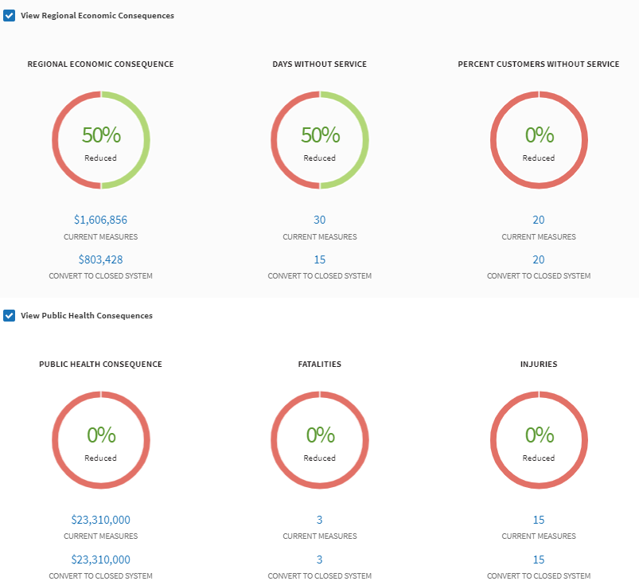
Figure B7. Illustrative Regional Economic and Public Health Consequences for the Convert to Closed System Plan under a Higher Rainfall, Stormier, SLR – 2050 Scenario

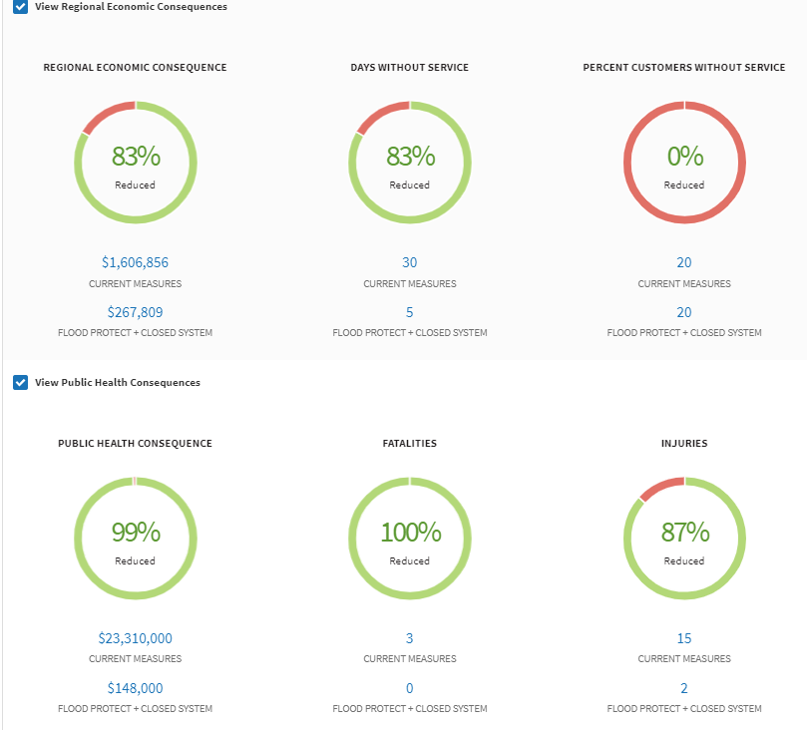
Figure B8. Illustrative Regional Economic and Public Health Consequences for the Flood Protect + Closed System Plan under a Higher Rainfall, Stormier, SLR – 2050 Scenario

